**Megha Sharma**

**Pavani Sree Lakshmi Penumathsa**

**Reshma Reddy Thumma**

**Vinutha Nuchimaniyanda**

**Project Report E-Smart Application**

**Increment-4**

CS-5551 ASE

We have been able to implement the following features as part of the first ,second, thirdand final increments of the project.

1. User login, registration & validation
2. Home Page
3. Energy Analyzer includes
   1. Energy utilization analysis with Green Button file (annual and monthly utility data analysis)
   2. Energy utilization analysis without Green Button file
   3. Yardstick score( give a score on a scale of 0-10 based on user’s energy consumption)
4. Home Comfort
5. Find Energy efficient Neighborhood
6. Survey based Budget my year, Recommendation and Tip of the day
7. My Community
8. Discussion Board

**Web Client/Mobile UI Design**

To design the UI, we have used a combination JQuery, HTML5 and CSS. Most of the features have been supported by google and other web apis.

**Class Diagram**

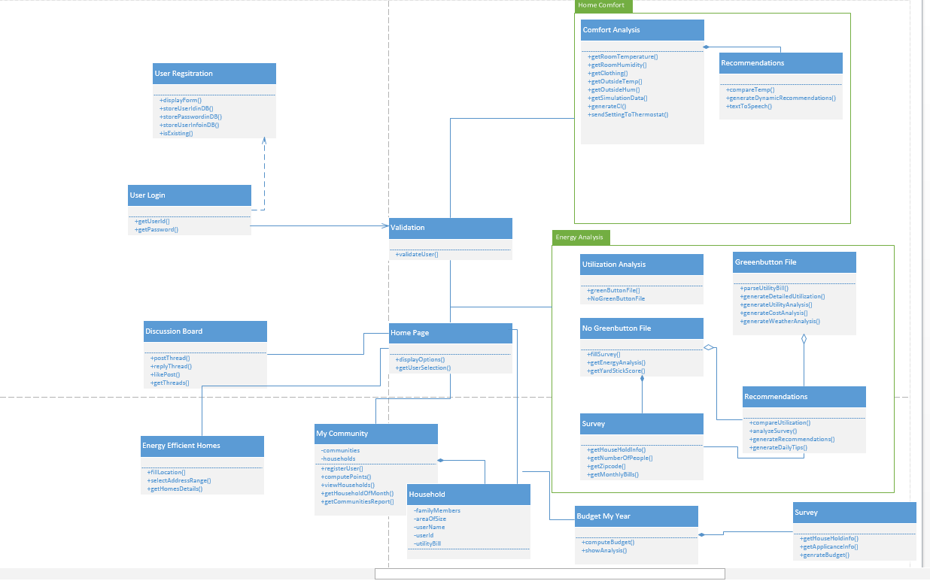

**Sequence Diagrams**

1. User Login and Service request

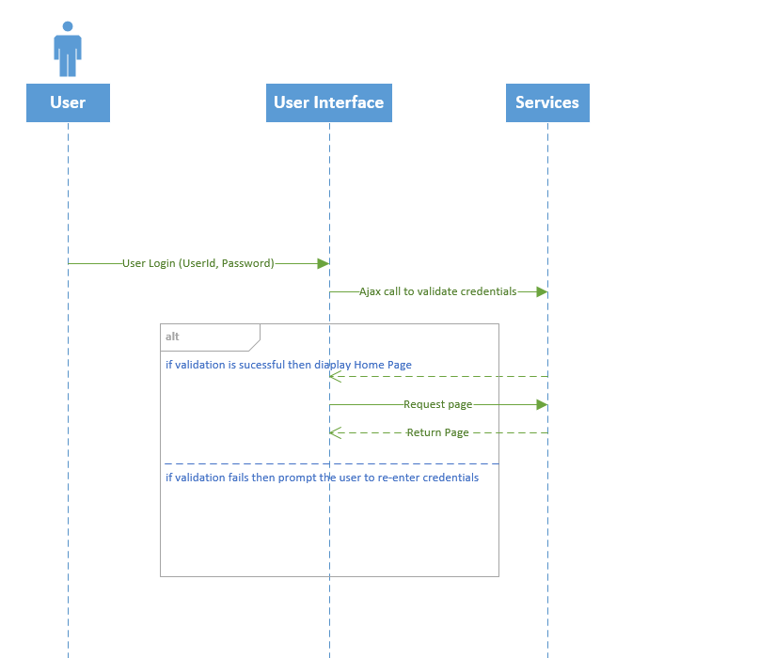

1. User Registration

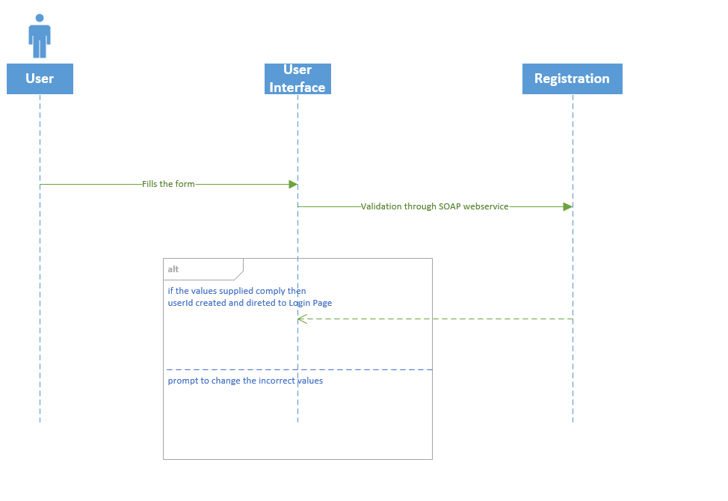

**System Architecture Design**

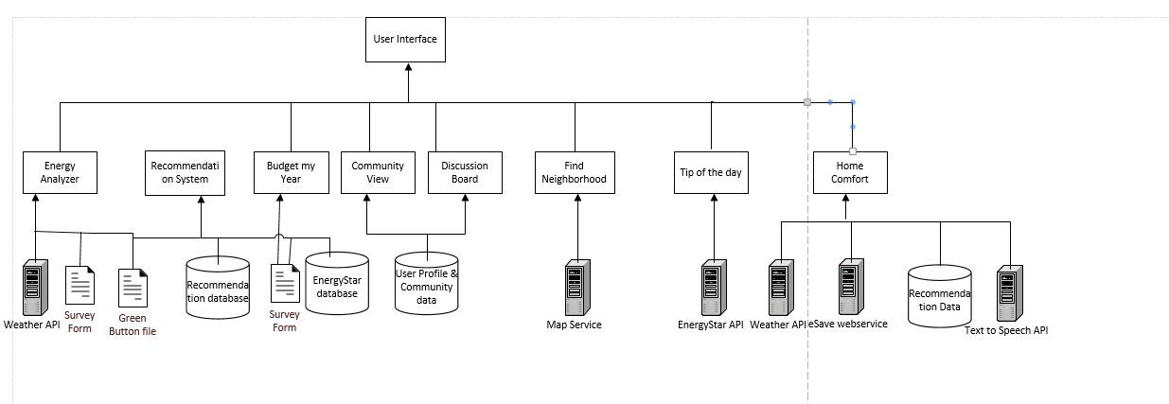

**Implementation Details**

The details of the features are below:

**1) User Login & Registration**

**Webservices/API:**

* We plan to use SOAP webservices to perform verification of user credentials and for storing user credentials in the database.

**Design & Implementation details:**

This page will allow the user to login to the E-Smart website. The validation is done based on the username and password entered by the user. If the validation is successful, it navigates to the website’s Homepage. If either username or password doesn’t match it shows the error message and will not allow the user to login to the website.

**Login and New user registration:**

**Sign up page:**

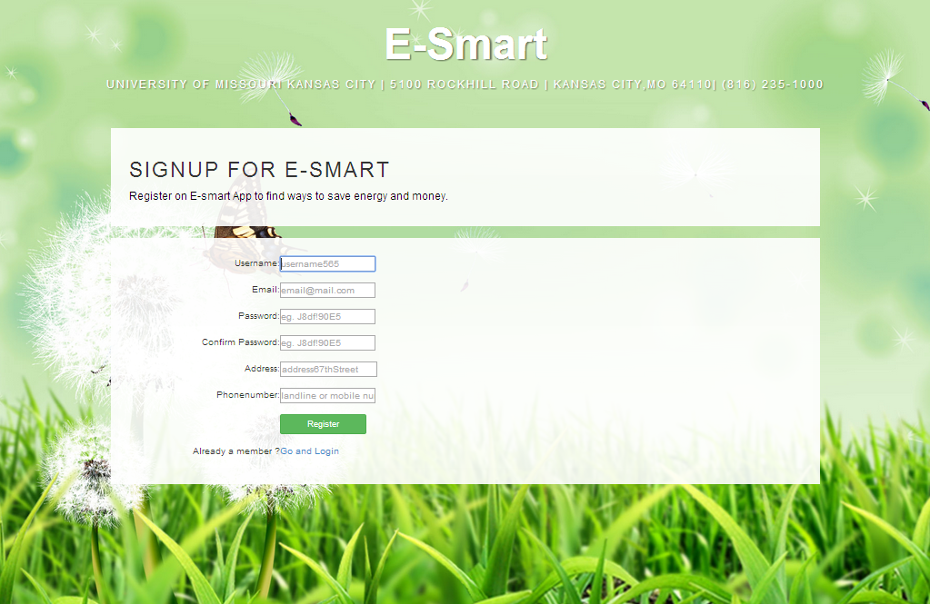This page allows new users to register on **E-Smart** website.

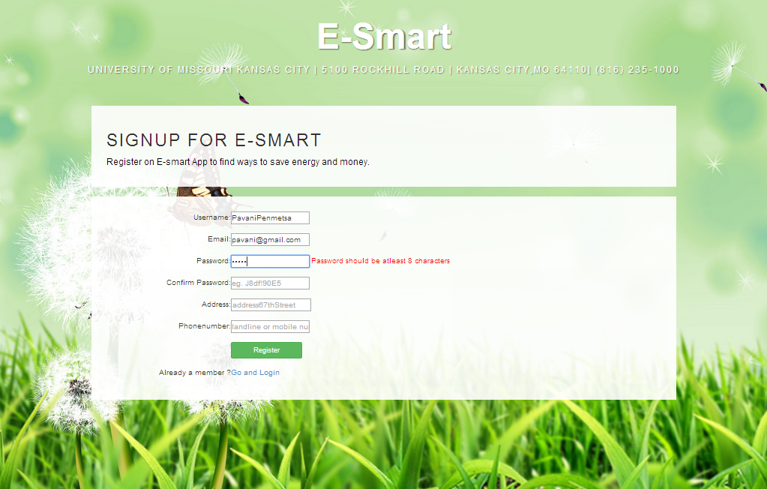During sign up, if the user enters password less than 8 characters it throws an error “Password should be at-least 8 characters” and doesn’t allow to proceed further, until the user enters valid password.

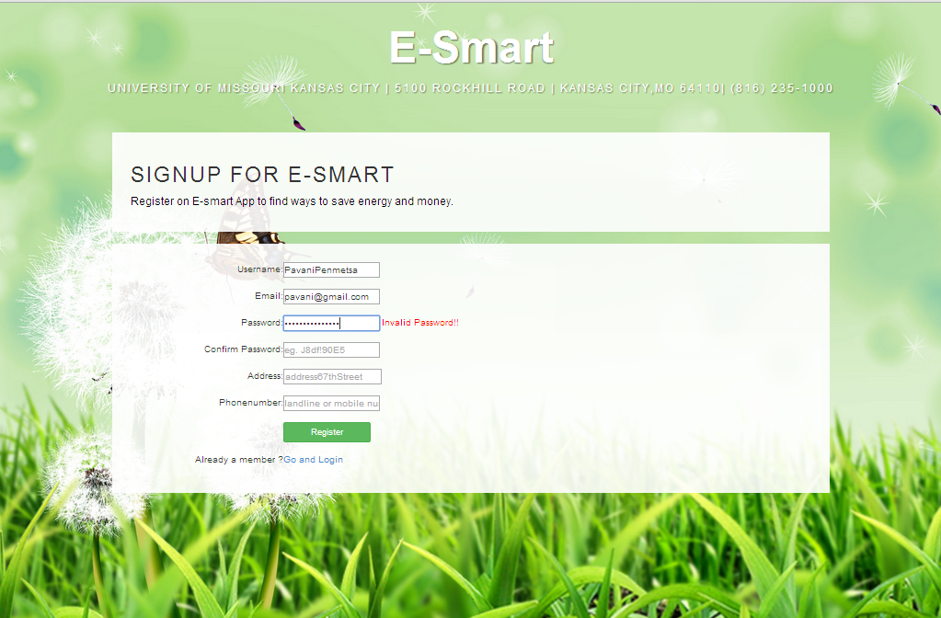During sign up, the valid password should contain atleast one upper case, one lower case, one numeric and one special character. If the user enters invalid password it throws an error “Invalid Password” and doesn’t allow to proceed further, until the user enters valid password.

During sign up, the password and confirm password values should match otherwise it throws an error “Passwords does not match. Please re-enter” and doesn’t allow to proceed further, until the user enters valid password.

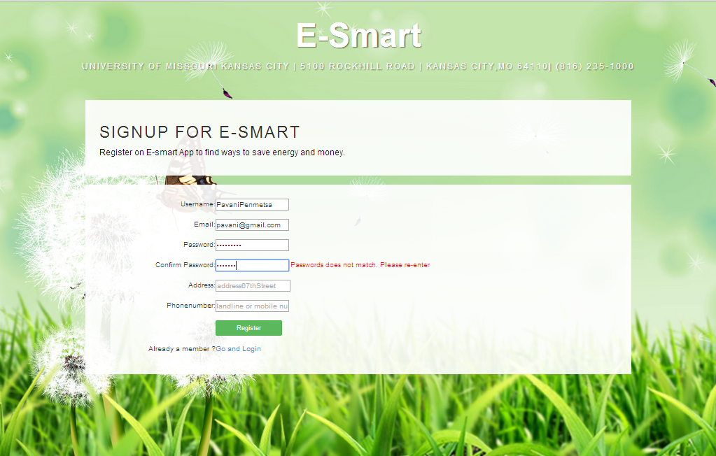

During sign up, if the user enters all details correctly and clicks on signup button, he will be navigated to the Login page.

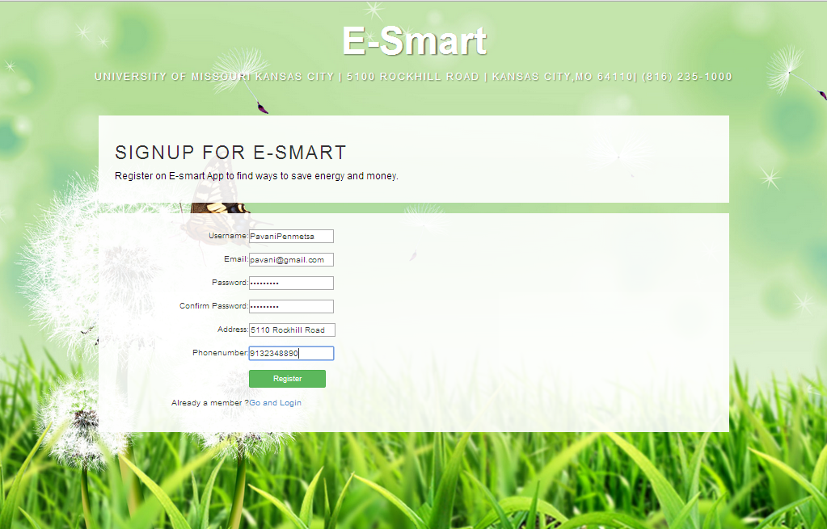User can directly go to Login page by clicking on the Go and Login button.

**Login page:** This page will allow the user to login to the E-Smart website. The validation is done based on the username and password entered by the user. If the validation is successful, it navigates to the website’s Homepage.

If the user is new, he can go to sign up page and register by clicking on the Register button.

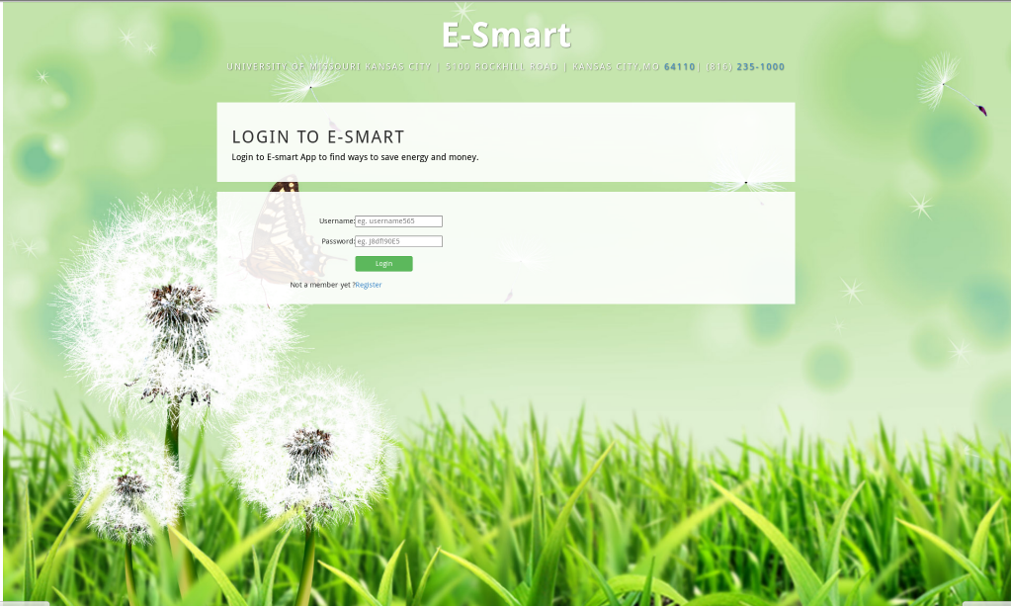

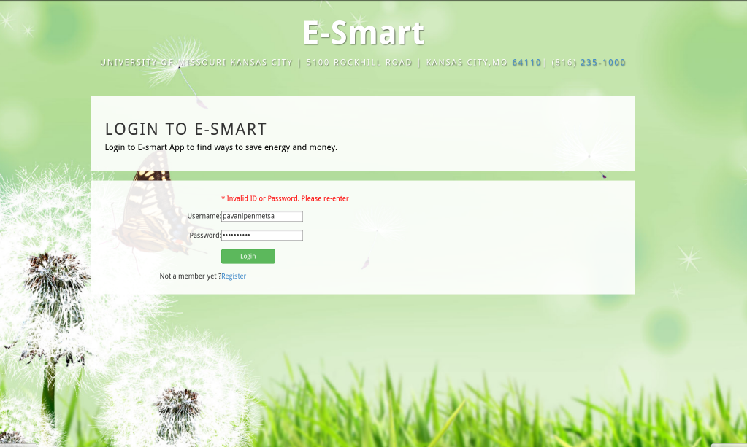If either username or password doesn’t match it shows the error message “Invalid ID or Password. Please re-enter” and will not allow the user to login to the website.

The registered user details are stored in **users** table in the sql server database.

While logging in the username and password values are verified with the values that already exist in the users table. Once the user enters valid username and password he will be navigated to the **Home Page**.

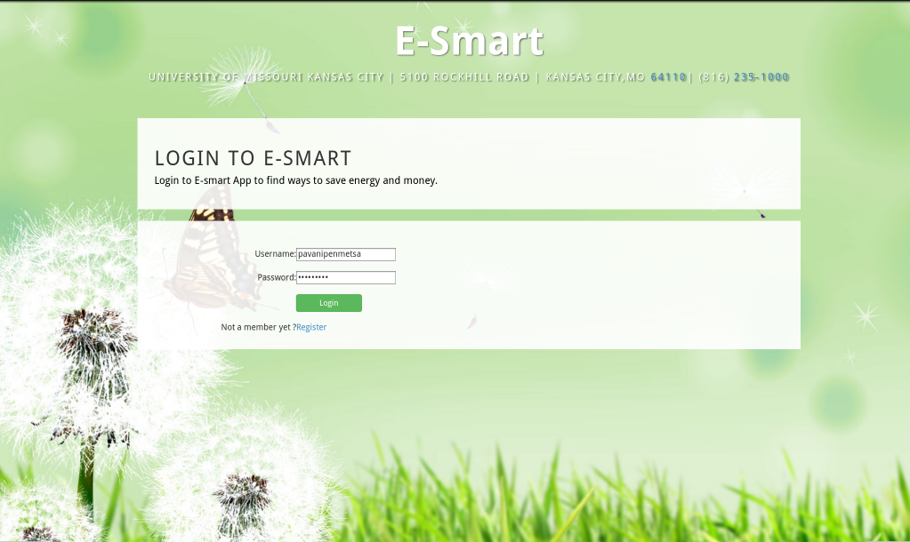

HOME PAGE:

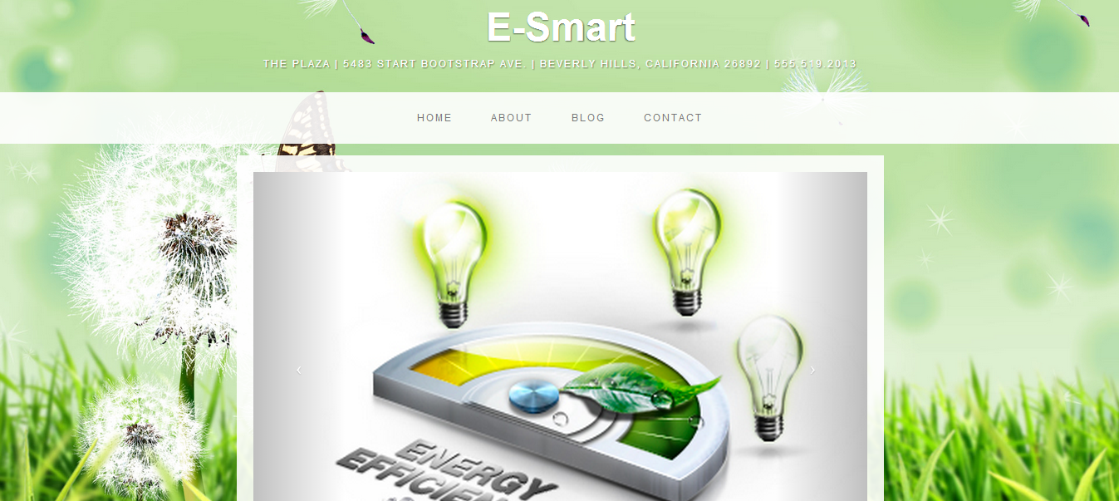

Detail Design of Services

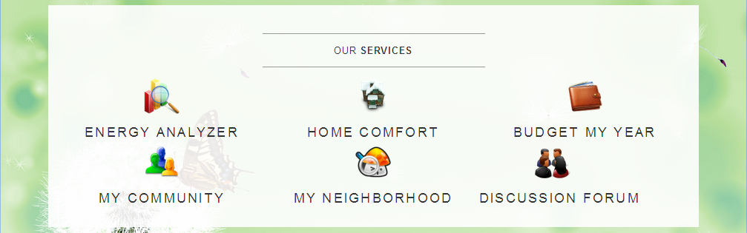

**2) Energy Analyzer**

Charts

Import Existing Services/API

1. Google Visualization API Source
2. Visualization ComboChart for Energy Analysis Monthly data.
3. Visualization AreaChart for Cost difference data

Detail Design of Services

Two main components of energy analyzer are charts and yardstick. Charts are generated for the data supplied by user and yardstick score to educate user about his energy consumption. User will be navigated to the first page of Energy Analyzer from the home page. User can fill in details such as Number of people living in the household and area of the house in Square feet which will be used calculate the yardstick score.

Here, user can choose either green button file or non-green button data

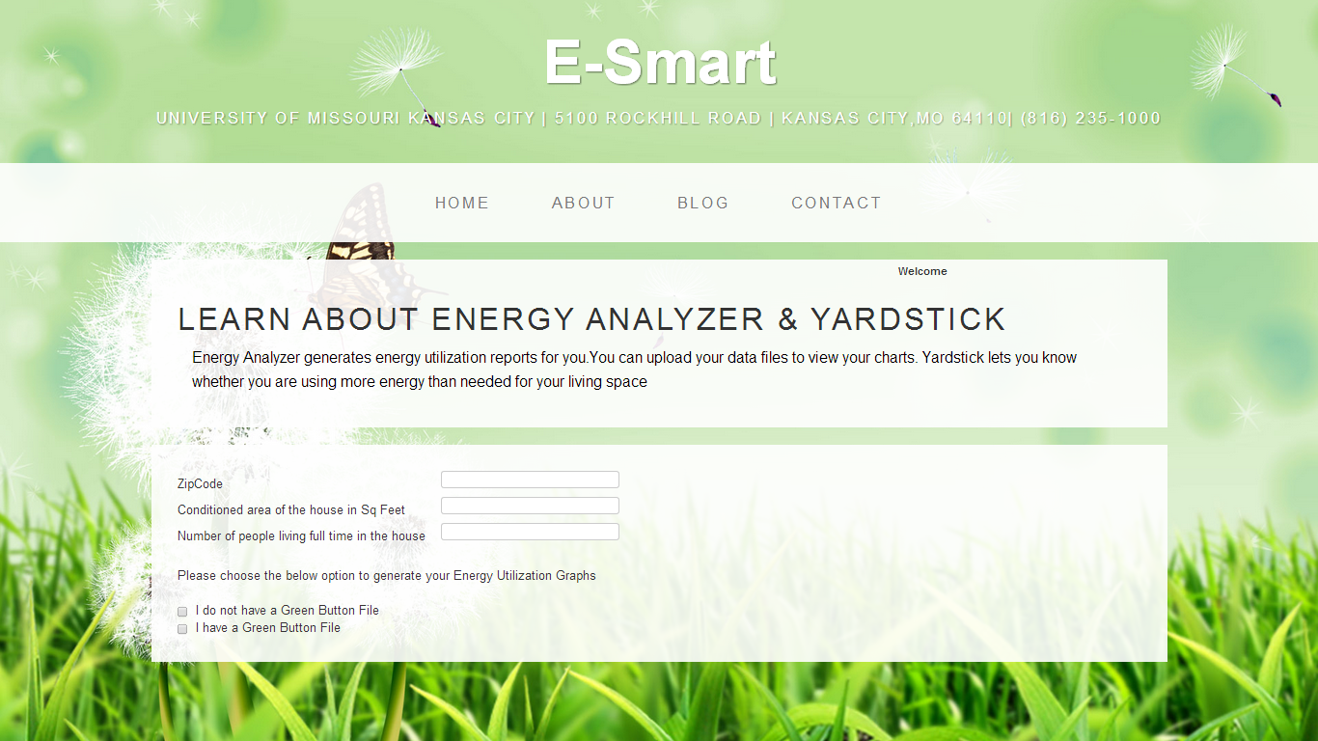

When I do not have green button file checkbox is checked, the user will be provided with the option to select which year he wants to view the data and user should enter the values in kilowatts for each month that will be generated as a graph.

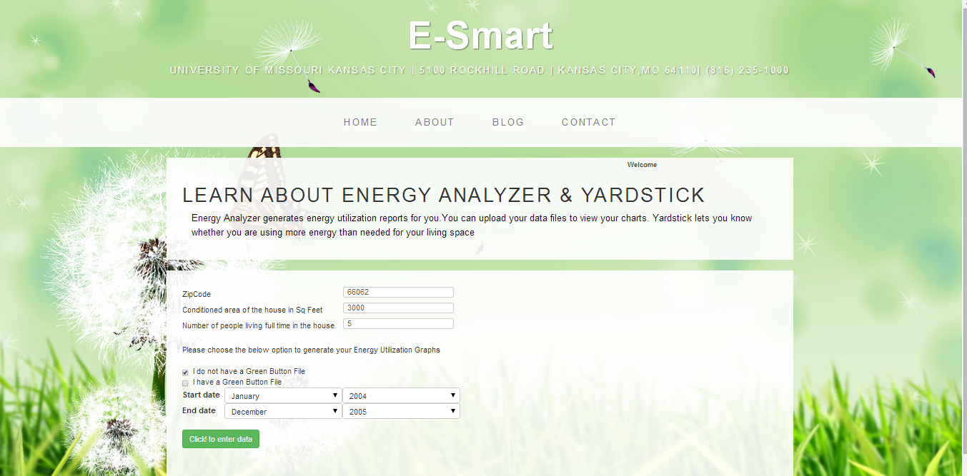

Below chart is generated once the user fills the energy values and clicks show chart.

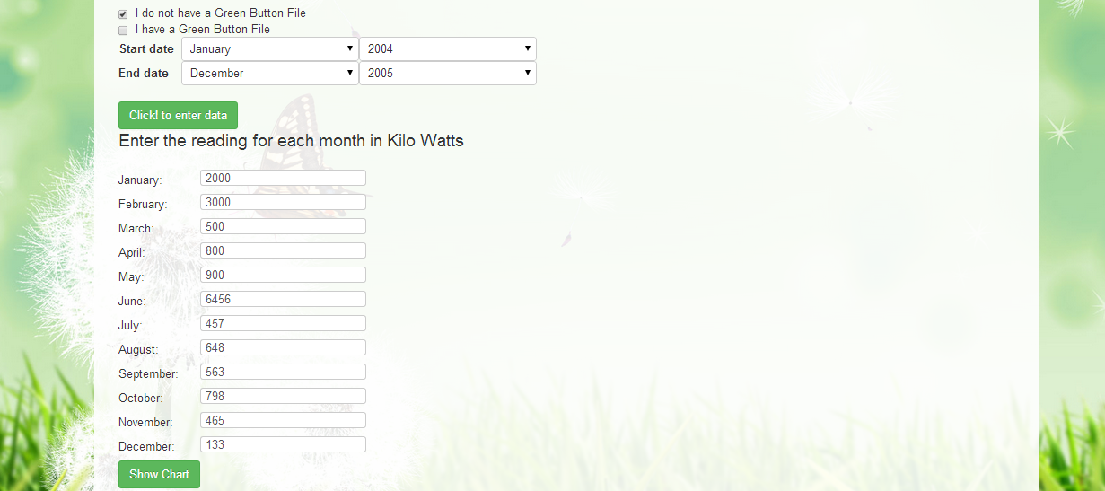

Chart uses the kilowatts data supplied by the user where as Yardstick uses the living area and number of people in the house hold to calculate a value which is used to educate user whether he is using more energy than needed for his living space.

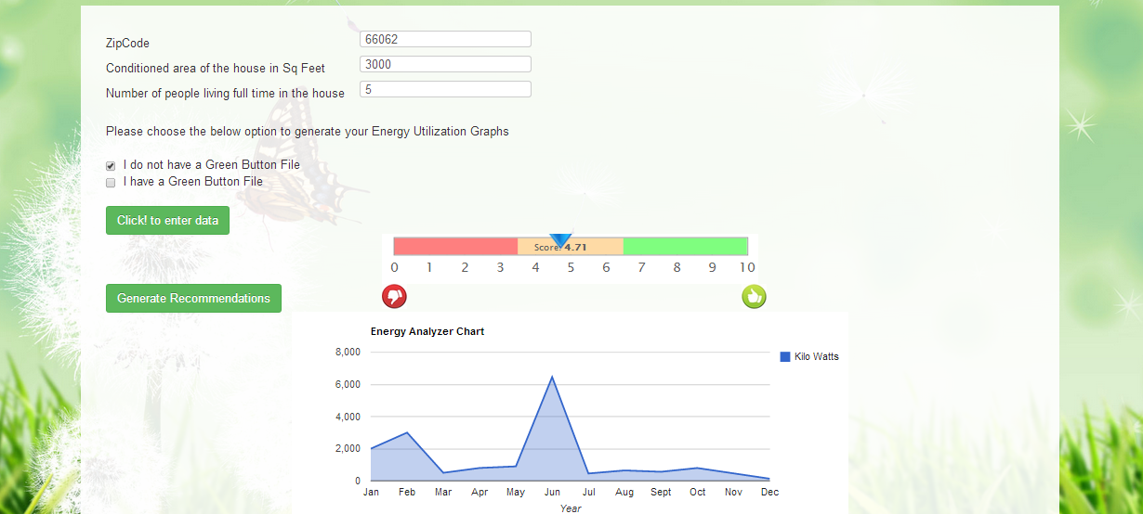

Generate recommendations button will generate energy saving tips for the user based on the yardstick score.

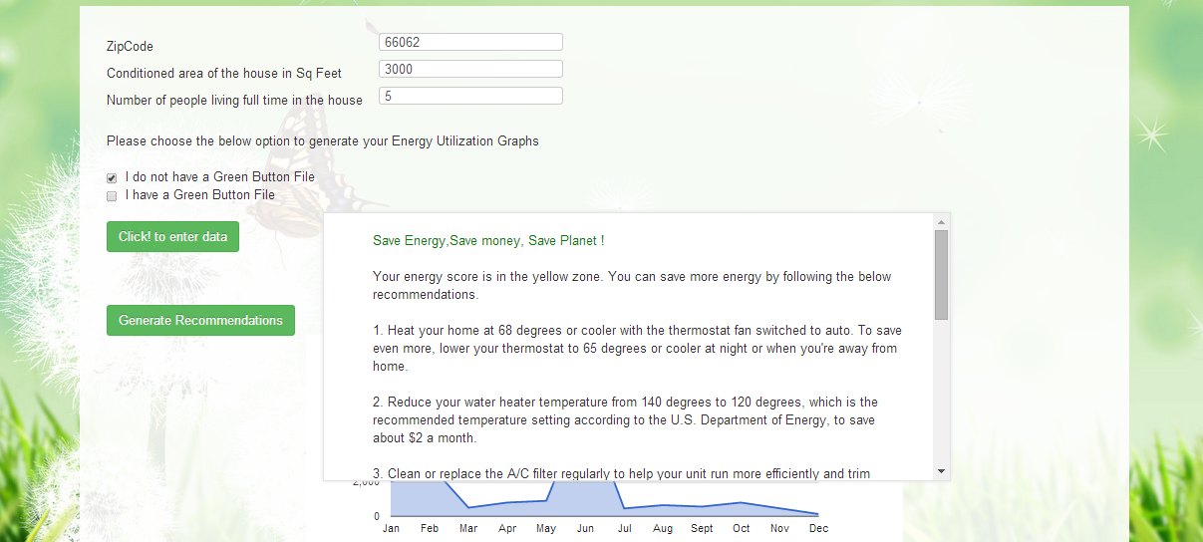

If the user checks, I have Green Button File checkbox. He will be navigated to the dynamic charts page where he can upload the file and two charts are generated.

1. Energy analysis chart with variation in Temperature
2. Cost analysis chart

These charts are for 45 days of data.

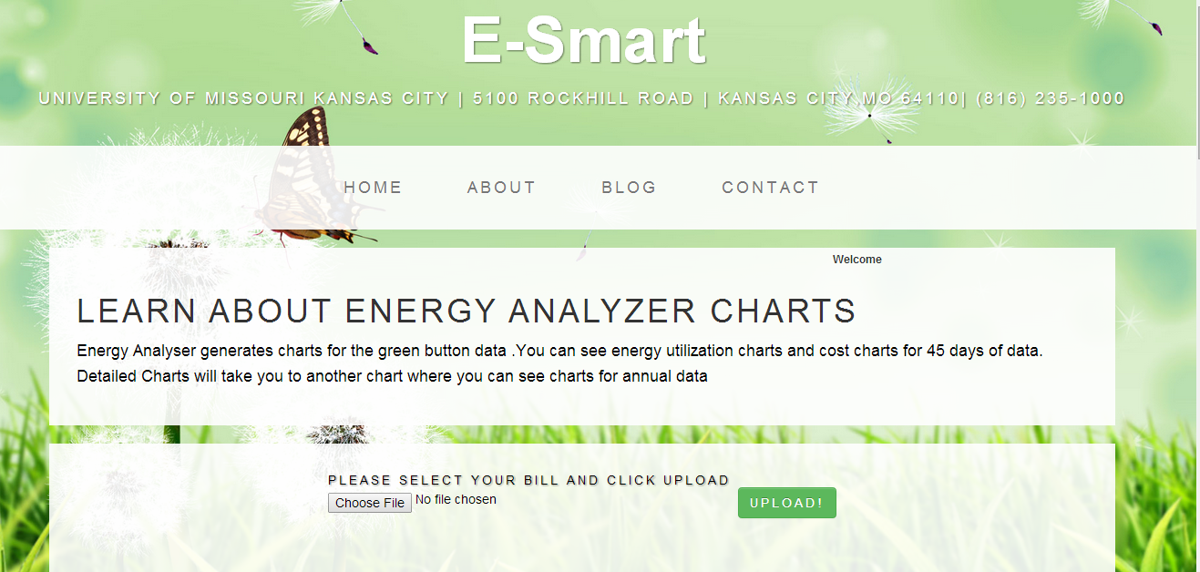

Below is the screenshot of energy analysis chart with variation in temperature.

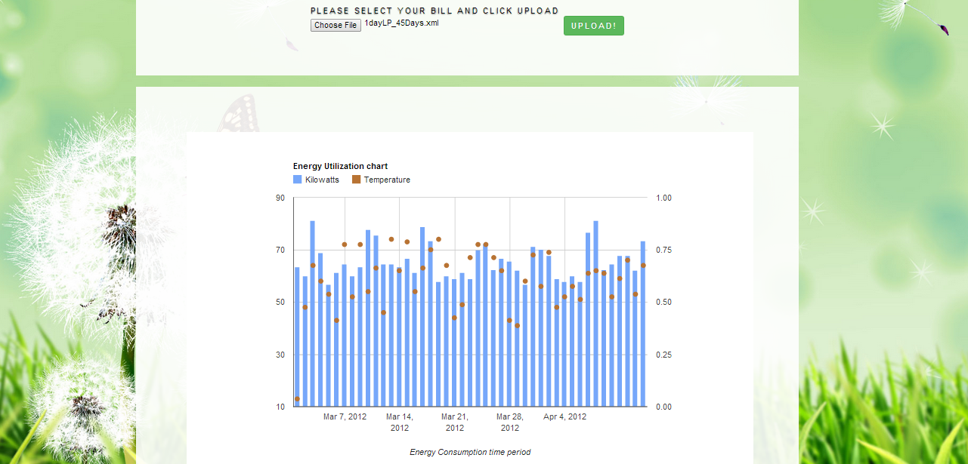Below is the screen shot for the variation in the cost depending on the energy consumed for each day up to 45 days

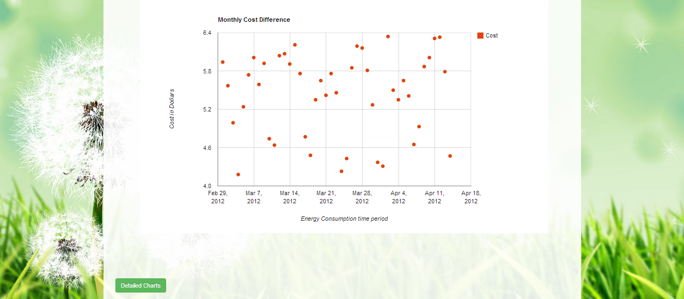

1. Detailed View:

After user selects green button file, he will be asked to browse ad upload a file as below

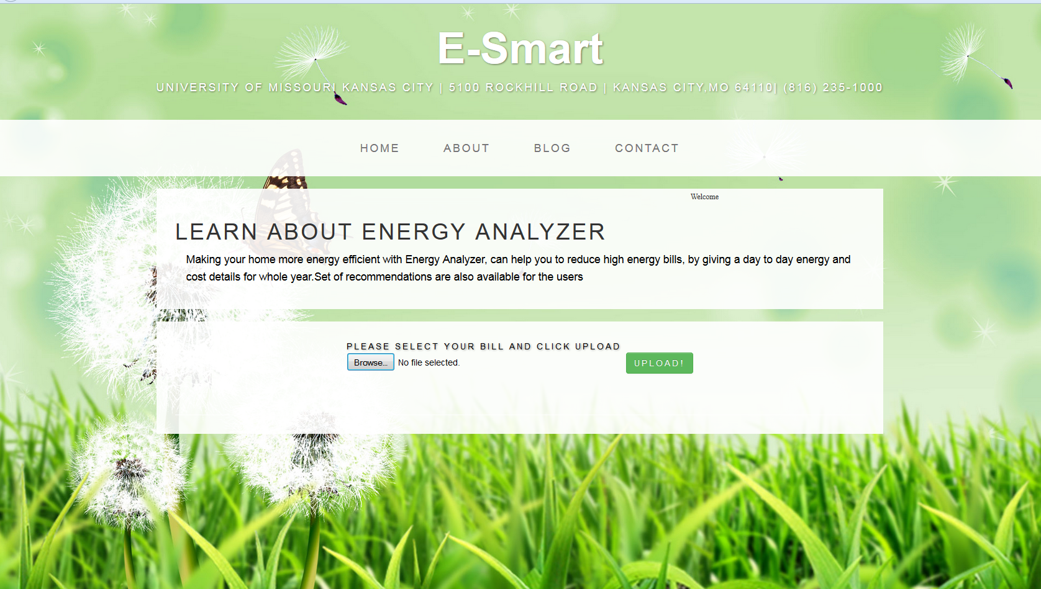

Once user clicks Upload button a detailed graph will be generated for whole year with the energy and cost value of each day.

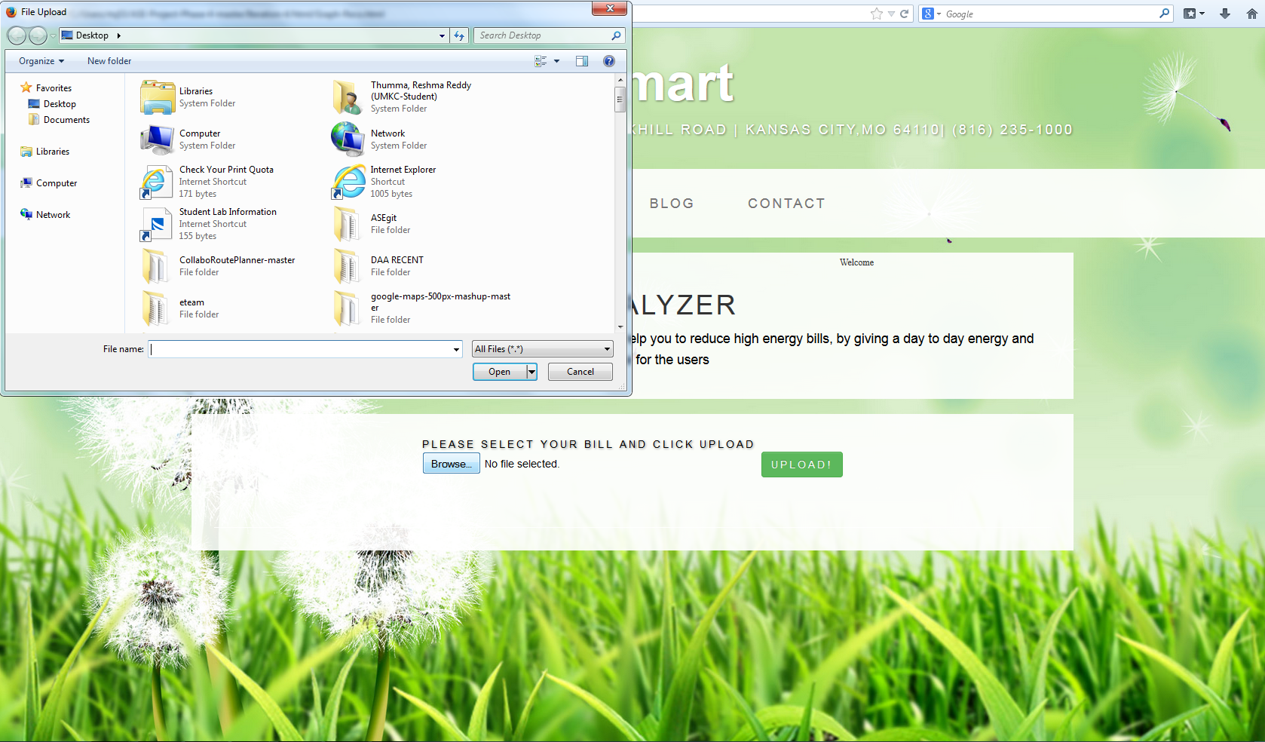

A detailed chart will be generated once the user clicks upload. And the chart will have a)Energy utilization details per day throughout year (b) Cost per KW

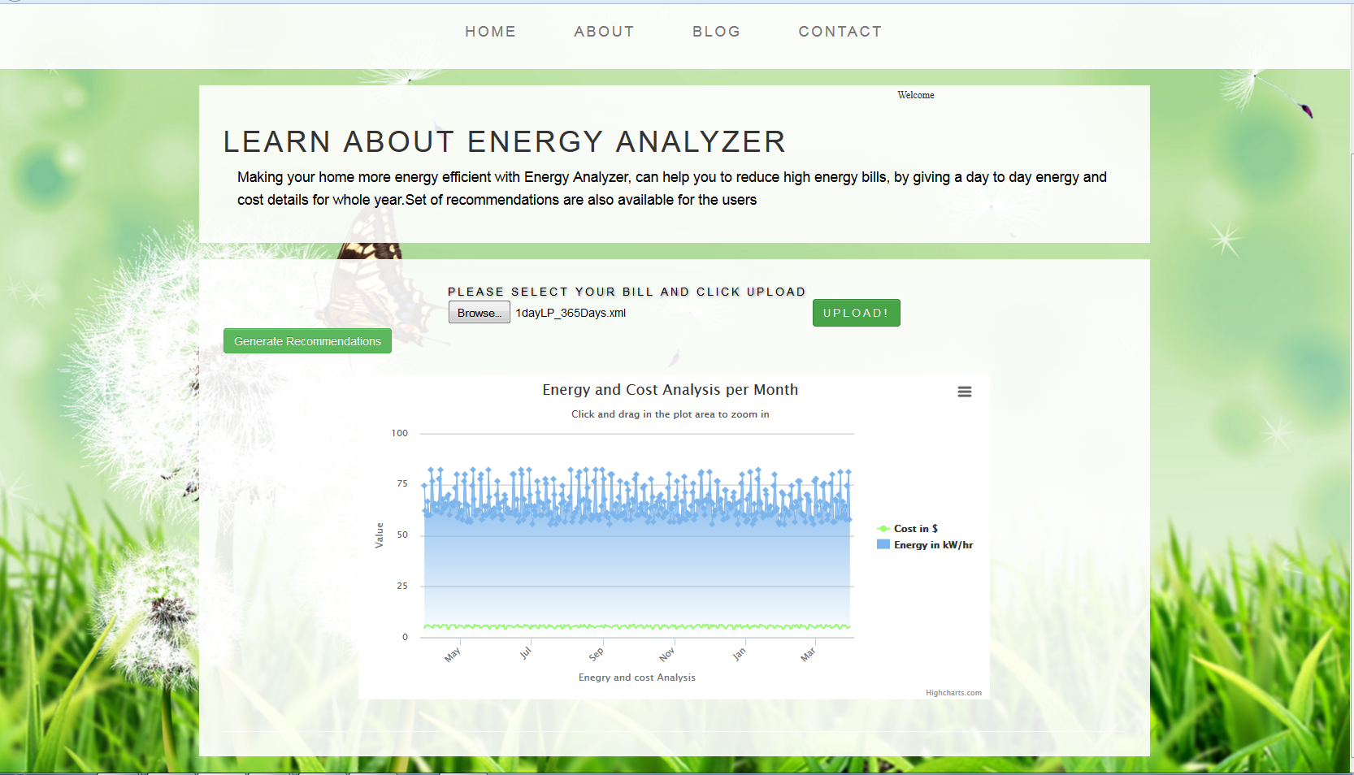

User will have an option to select only cost or energy as below

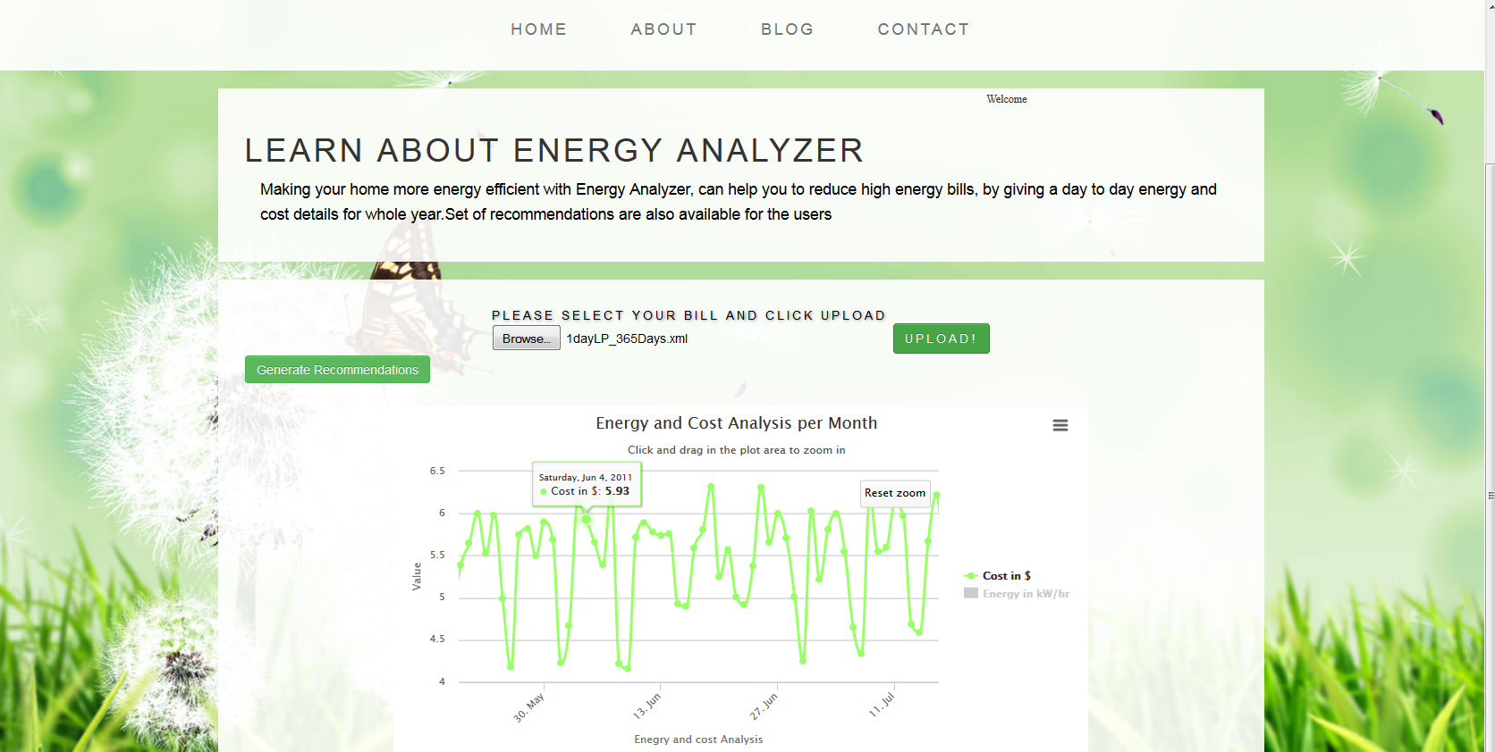

Or to view only energy consumed in KWH

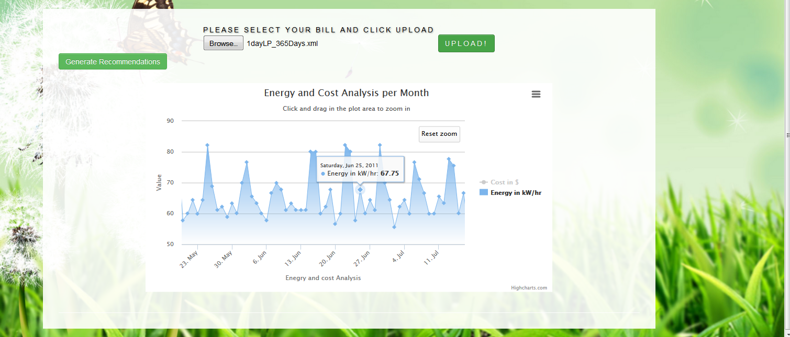

If user wants to conserve energy he can click “Generate Recommendations” He will be given a set of Recommendations as below.

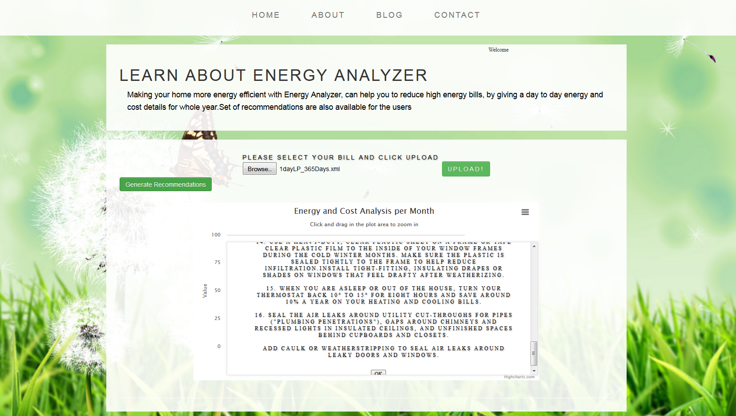

**3) Home Comfort**

**Webservices/API:**

* The geocode function supported by the browser has been used to detect user’s current location.
* The weather webservice by wunder “api.wunderground.com” has been used to populate the outside temperature and humidity.
* The jQuery UI sliders have been used for creating sliders on the home comfort page.
* The “google.visualization.Gauge” has been used to create the comfort index gauge.
* The text to speech service from tts.com has been used to convert to written recommendations to speech.

**Design & Implementation details:**

User Clicks on the Home Comfort Image and clicks on get started which opens a survey page

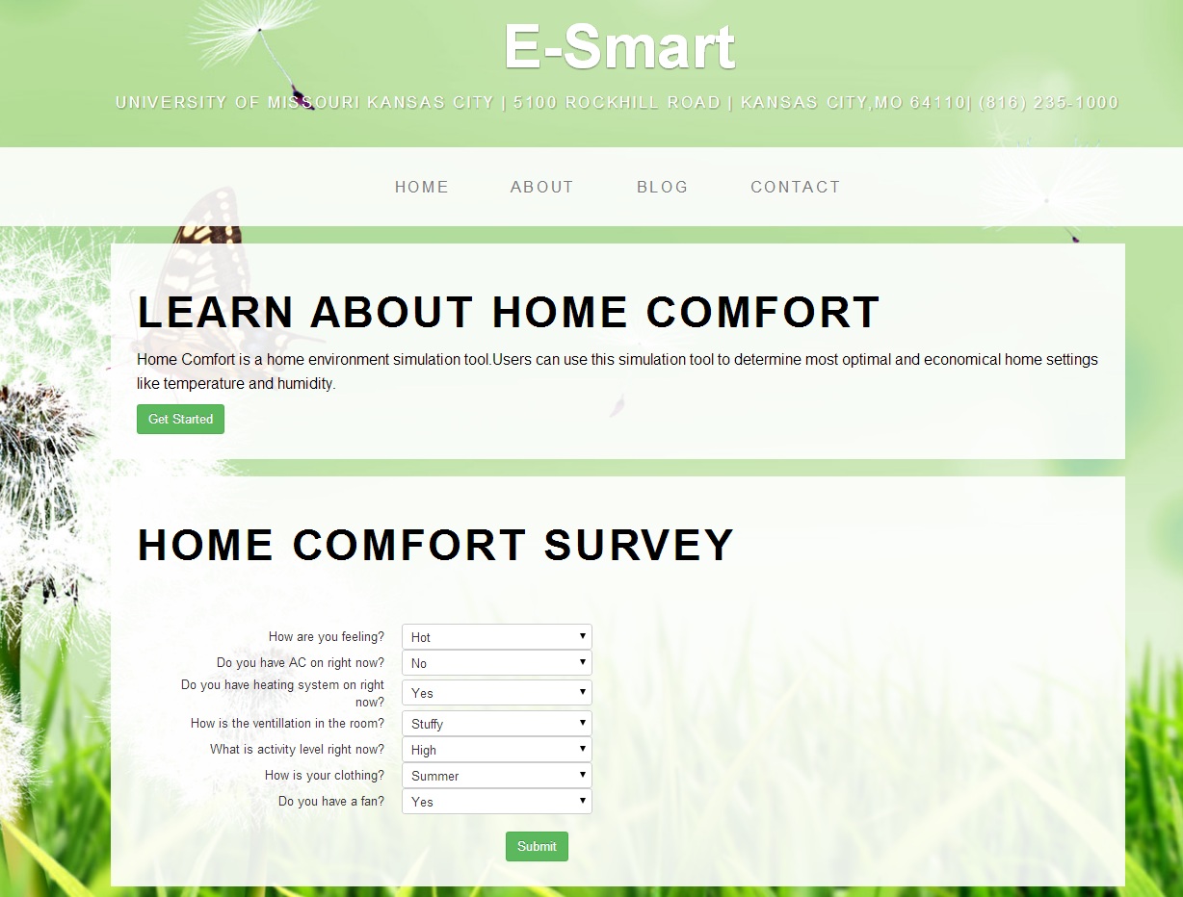

On clicking submit the system generates some recommendation on how the user ca improve the comfort settings of his home.

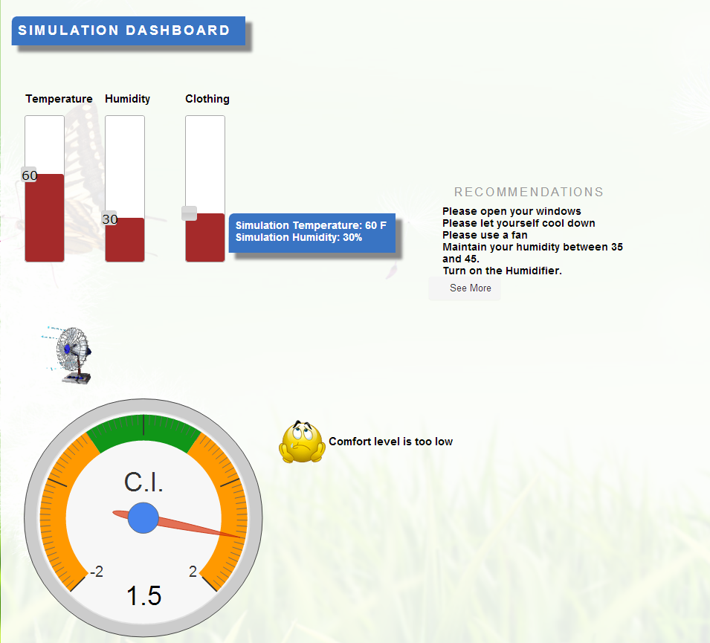

The Page displays the user’s current home temperature and humidity and computes the Comfort Index (Comfort Index computation using formulae is yet to be implemented) of his home environment. This page also shows the outside temperature and humidity and displays a message providing an explanation of the comfort index.

If the comfort index is outside the comfort zone (in green) then it also shows a set of recommendations to make the comfort index fall into green zone. These recommendations are created by performing computation on his current home environment.

If the user sets the temperature too high or too low then the system prompts an alert message.

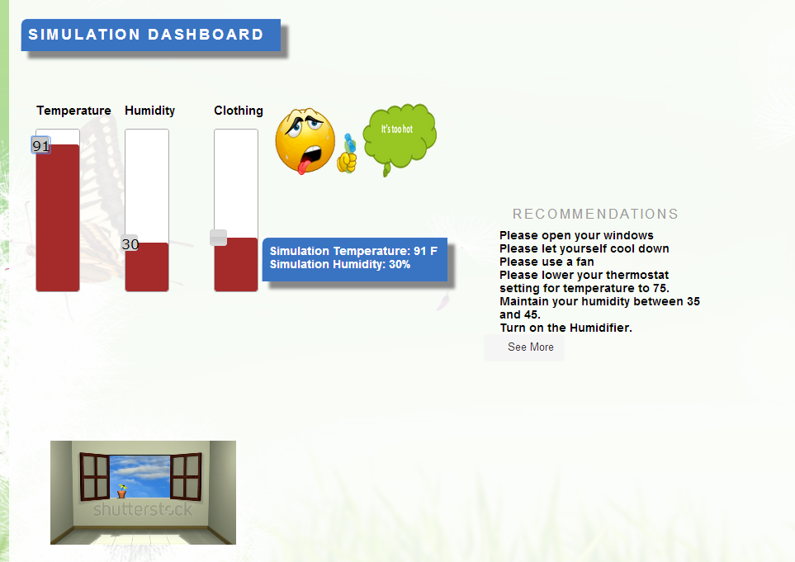

**4.Energy Efficient Houses**

Import Existing Services/API

1. Google Maps API for maps in find energy efficient houses
2. Google Maps directions API in find energy efficient houses

Finding energy efficient houses in major areas of the kansas. This feature allows user to select energy efficient houses in major areas of Kansas. Most of the houses are under construction. Information is collected from major real estate websites like Zillows ..etc. This feature allows the user to look at the notes available for each house where the list price and address is provided along with important notes about the house . User can see the directions for each house.

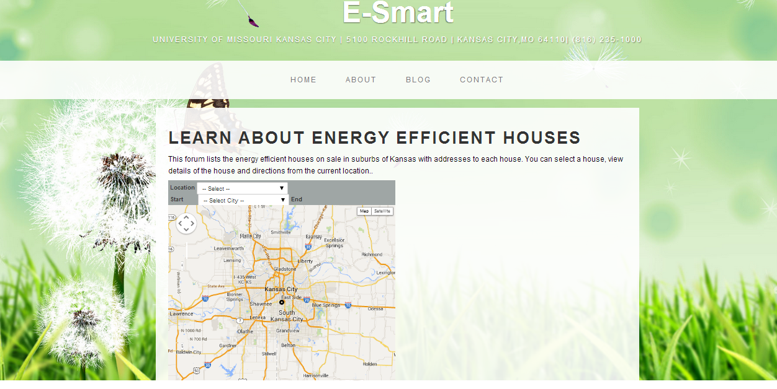

Below is the screenshot for number of different cities that user can find the energy efficient houses. List of notes is available on the right side of the page with the details of each house in a city selected from dropdown. Notes are implemented using soap database.

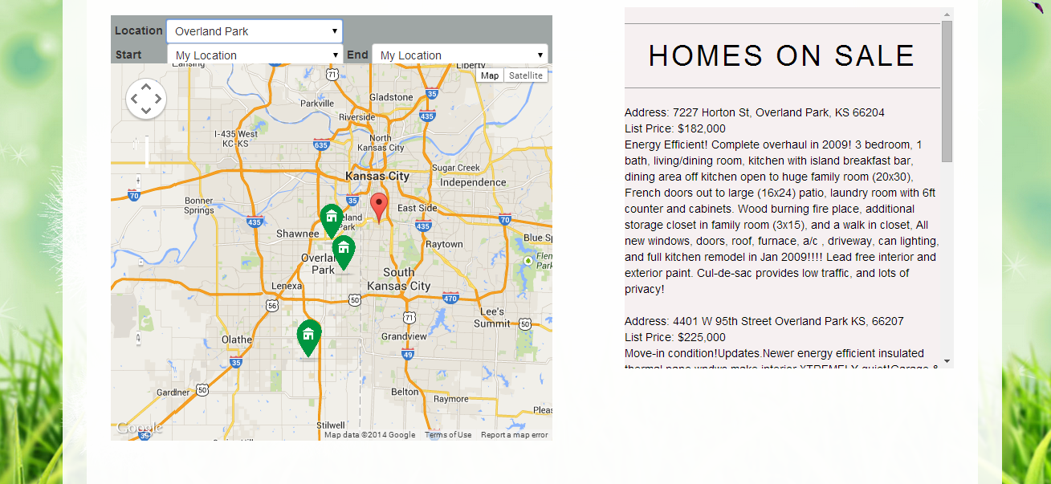

Start and End position on the map panel lets the user to see the direction for a particular location

My location is configured to UMKC latitude and longitude.

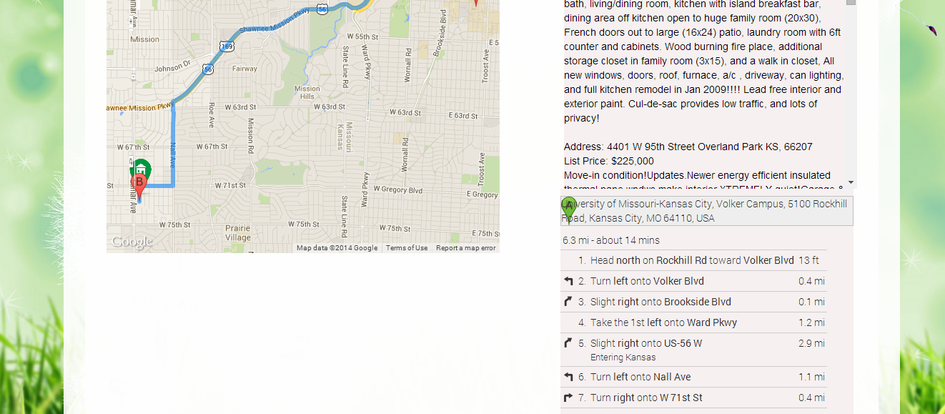

**6) Survey based Budget my year, Recommendation and Tip of the day**

**Webservices/API:**

* In future we will be using EnergyStar API to determine each appliance’s approximate energy consumption.
* Google visualization api has been used to generate charts.
* jQuery toggle used in recommendations page.

**Design & Implementation details:**

User clicks on the Budget My Year option which takes him to the survey page.

Below is the survey page where user can gets the options to fill household survey and Appliance Information.

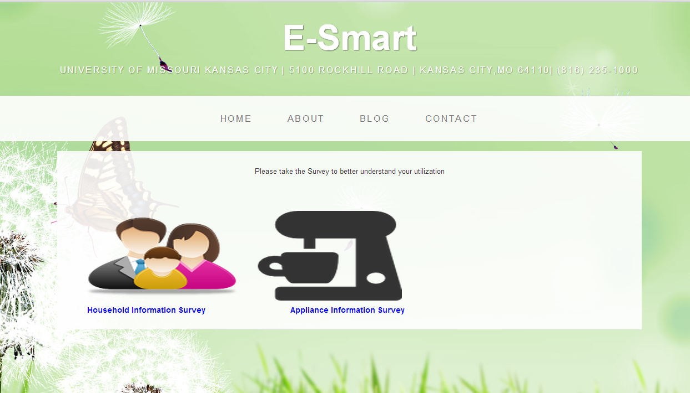

Below is the Household information part of the survey.

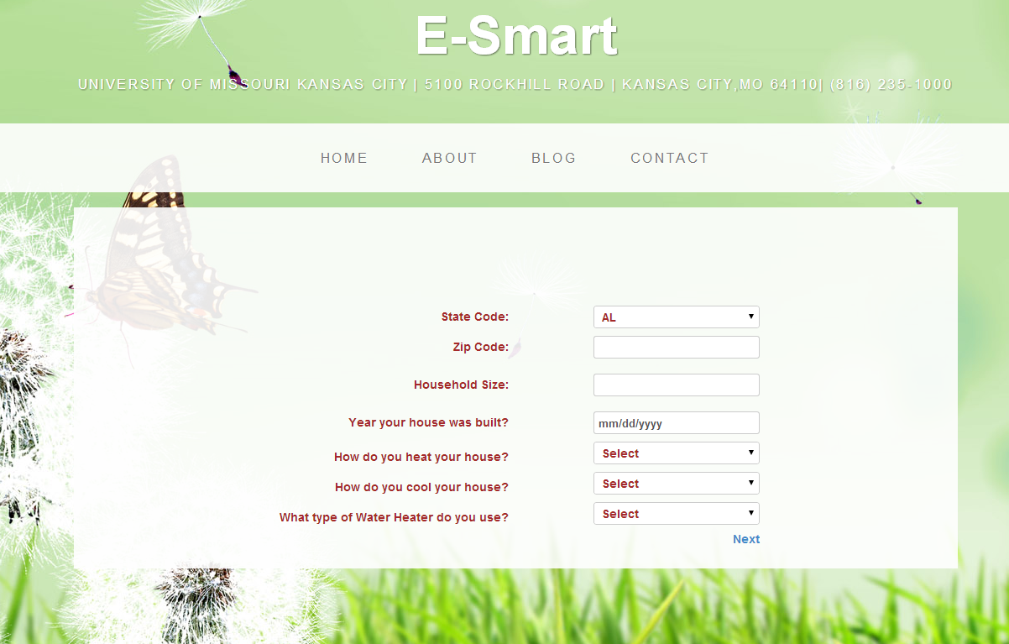

The next page takes him to the appliance based survey.

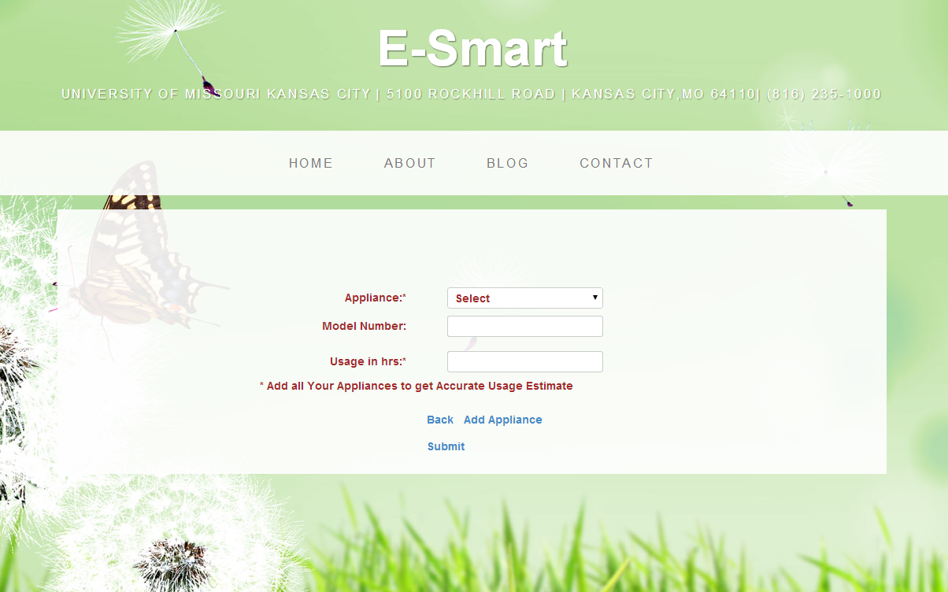

After entering all the appliances and clicking on submit, the user can see his budget and the

contribution of the entered appliances to his budget.

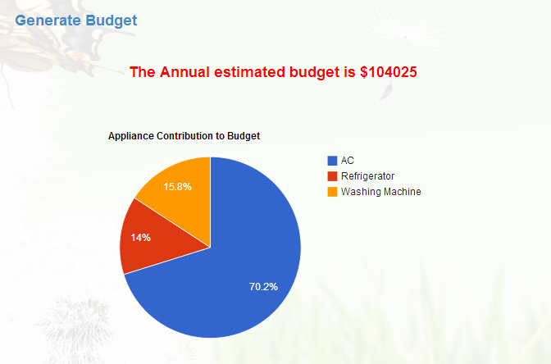

Clicking on generate recommendations takes him to another page which displays a set of appliance utilization recommendations generated based on the survey. A toggle feature in jQuery is used while designing this application. User can have a choice of selection which appliance recommendation he needs.

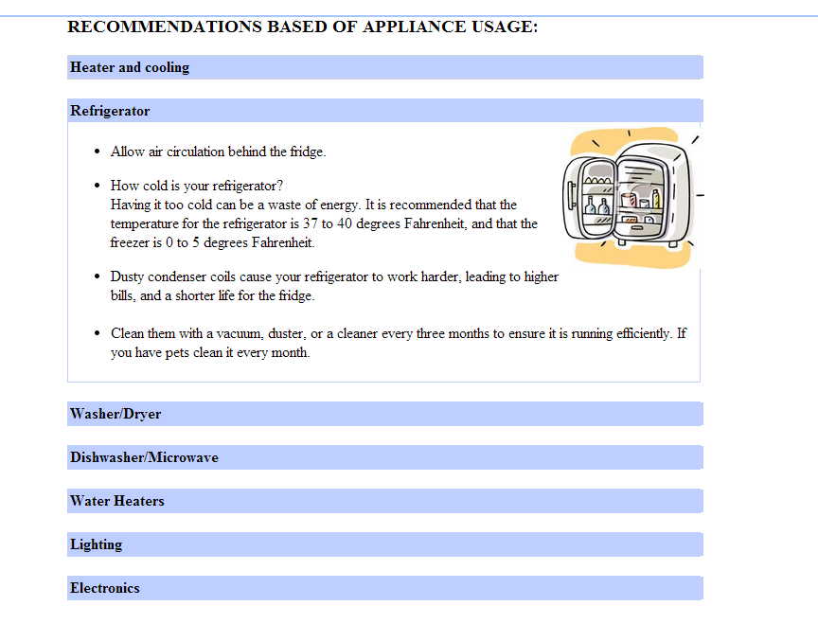

**7) My community -Home Page:**

The user name appears at the right hand side of the page. Here **My Community** button is available.

**My Community:**

My Community is one of the features provided by the E-Smart application. The purpose of this feature is the user can compare his utility bill with his neighbors and can get reward points based on the energy utilization of all the people those live in the same community. The user’s bill will be compared to his neighbors who live in the same community.

By looking at his reward points he will get an idea about his energy consumption and can implement ways to save energy and also save money.

He can also see all his neighbor’s reward points, who live in houses in the same community and see where he stands.

Three features:

* Compute his reward points for each month.
* View all his neighbors reward points who live in same community.
* View the near by communities reward points, pointing the communities on google maps.



When the clicks on **My Community** button, he will be navigated to **Join My Community** page, if he is not already part of **My Community**.

**Join My Community:**

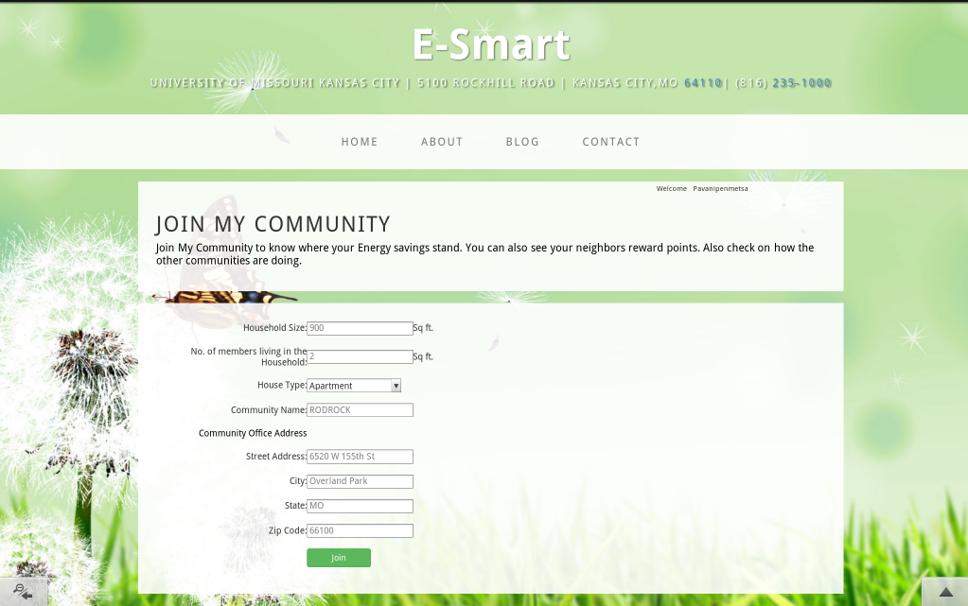

In the **Join My Community** page the user can enter his house hold size, house type, how many people live in and the community he lives in with its office address. After filling these details, he can click on **Join** button to join My Community.

The utility bill details are stored in the MyCommunity table in sql server database.

The community address is saved to show the communities with their energy saving reward points on google maps.

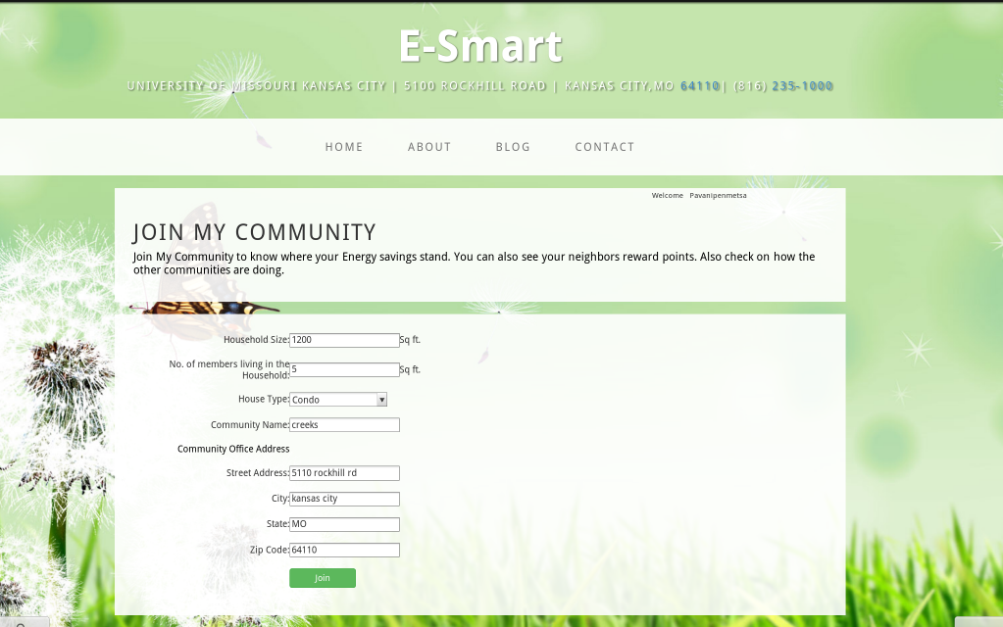

He will be navigated to the **My Community** Page where he can actually enter his utility bill details and get his reward points.

**My Community:**

The user can enter utility bill amount, utility bill month and utility bill year and click on the **Compute Reward Points** button. No to enter the house related details everytime.

**Compute Reward Points:**

If the user has already computed his reward points for the current month, then those details will be loaded in this page automatically.

The user can update the details if he makes any mistake and can compute his reward points again. If the same utility bill details for that user already exists in the database, then the details will be updated with the correct utility bill amount the user entered and then computes the reward points.

The utility bill details are stored in the utility_bill table in sql server database.

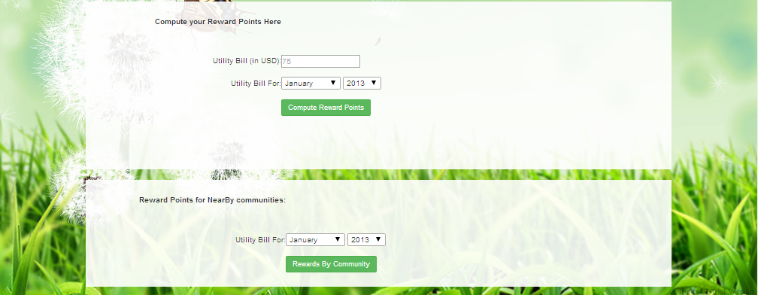

This will compare his bill amount with his neighbors and gives his reward points for that month and year.

The reward points are shown with the gauge meter with values from 0 to 5.

If the reward points are 1 and 2, the color displayed is red.

If the reward points are 3, the color displayed is orange.

If the reward points are 4 and 5, the color displayed is blue.



**Community Reward Points:**

The user can view his neighbors reward points who live in similar houses by selecting the month and year he wishes and click on the **Community Reward Points** button. This will display the house details and his neighbors reward points in ascending order.

The reward points are shown with the gauge meter with values from 0 to 5.

If the reward points are 1 and 2, the color displayed is red.

If the reward points are 3, the color displayed is orange.

If the reward points are 4 and 5, the color displayed is blue.

The user will the least utility bill for that month in that community will be given Rank 1 and “The Best” badge is shown representing he tops.

The username, house type, household size and members live in are also displayed along with the reward points.

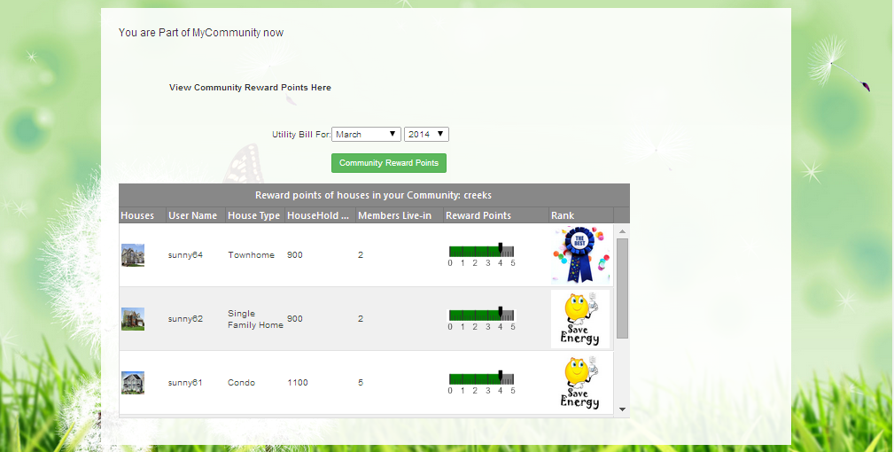

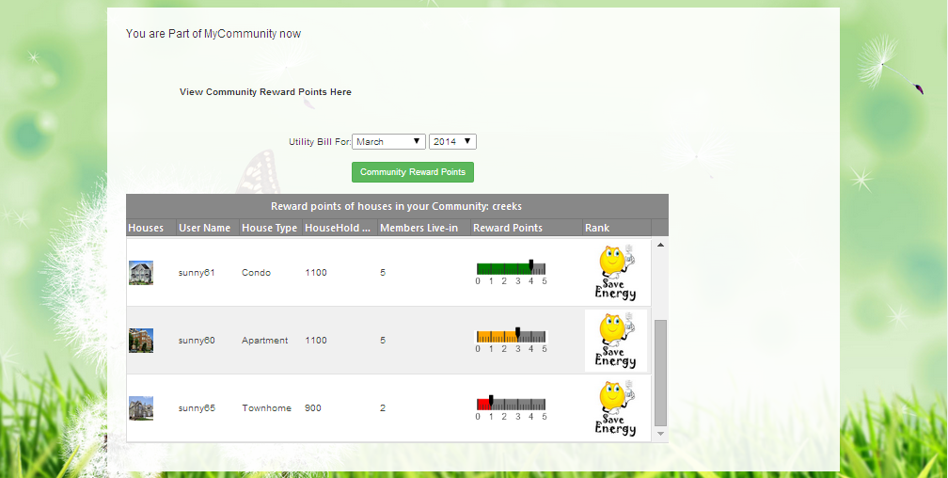

**Community-wise reward points:**

The user can select the month and year and click on Rewards by community button. The reward points are calculated for each community nearby the community the user lives in and displayed on Communities-Rewards page.



**Communities-Rewards page:**

The rewards points are calculated for each community based on the people’s utilities bills (who live in that community).

The reward points are displayed with the stars shown in the google map info window along with the community name.

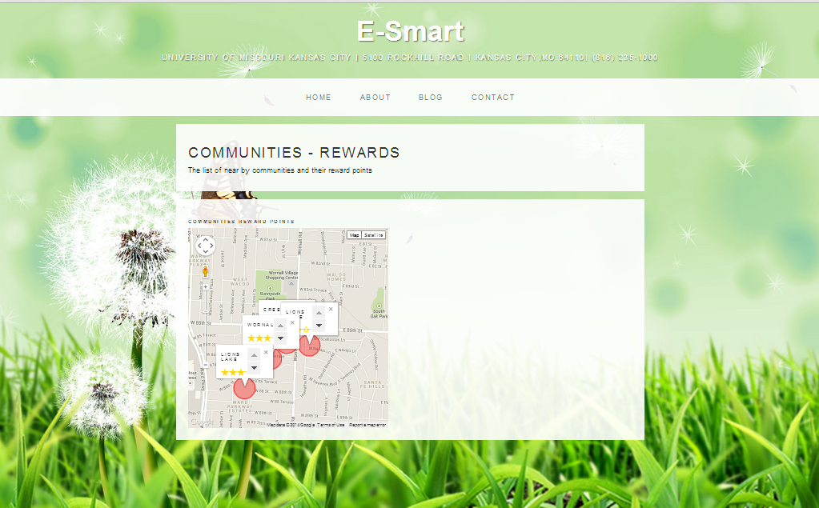

**Home Page:**

If the user is already part of My Community, he will be navigated to **My Community** page directly, when he clicks on **My Community** button in the **Home Page**. The screen navigation is as below.



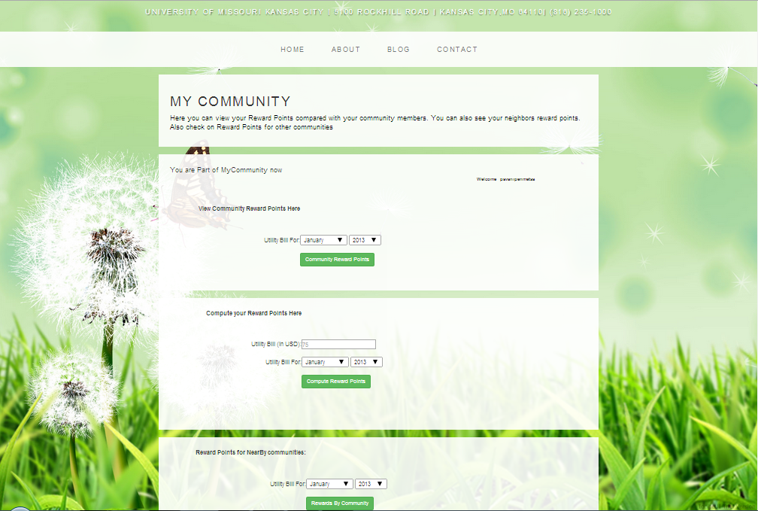

**Database details:**

**Users table:** Holds all the registered user details.

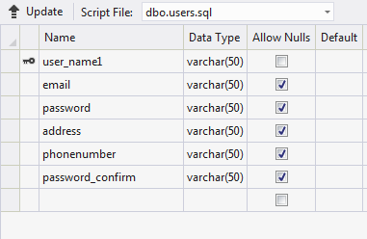

**MyCommunity table:** Holds all the users those are part of My Community.

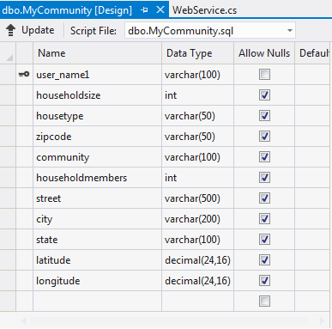

**Utility_bills table**: Holds all the utility bill details the users enter when they compute reward points.

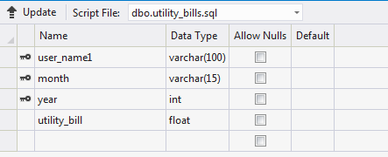

**API:**

<https://maps.googleapis.com/maps/api/js?v=3.exp&sensor=false>.

Languages/scripting: HTML5, JavaScript, C#

Tools: Visual Studio 2012

**Web service:**

The data filled in the pages are inserted and retrieved using the SOAP web service.

**Methods implemented in web service:**

* **GetUserData:** This method verifies the username and password validation in the E-Smart login page.
* **InsertUserData:** This method inserts the user data who registers for E-Smart Application.
* **getCurrentMonthYear:** Gets the current Month and Year.
* **selectCommunity:** This method fetches the user’s community details.
* **InsertMyCommunity:** This method inserts the user’s house details and community address from the JoinMyCommunity page.
* **InsertUtilityBill:** This method inserts the user’s utility bill amount, month and year from My Community page.
* **UpdateUtilityBill:** This method updates the utility bill, if the users chooses to update his bill.
* **CalculateRewardPoints:** This method calculates the user’s reward points for each month relative to his neighbors in the same community.
* **CommunityRewardPoints:** This method calculates all the people’s reward points who live in the same community as the user.
* **RewardPointsByCommunity:** This method calculates the reward points for each nearby communities.

**8) Dicussion Board**

**Webservices/API:**

* The geocode function supported by the browser has been used to detect user’s current location.
* The “google.visualization.Gauge” has been used to create pie charts for the appliance utilization .
* SOAP Webservices have been used to populate forums and store user replies and create new threads.

**Design & Implementation details:**

User Clicks on the Dicussion Board image on homepage.

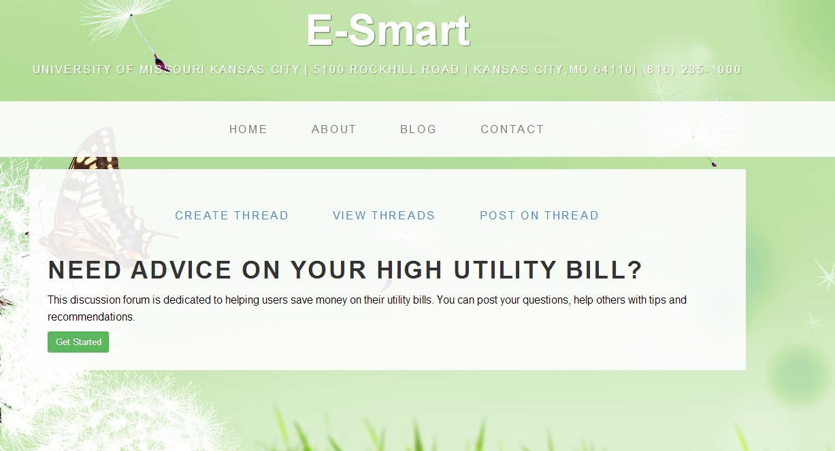

User can create Posts by clicking on create thread.

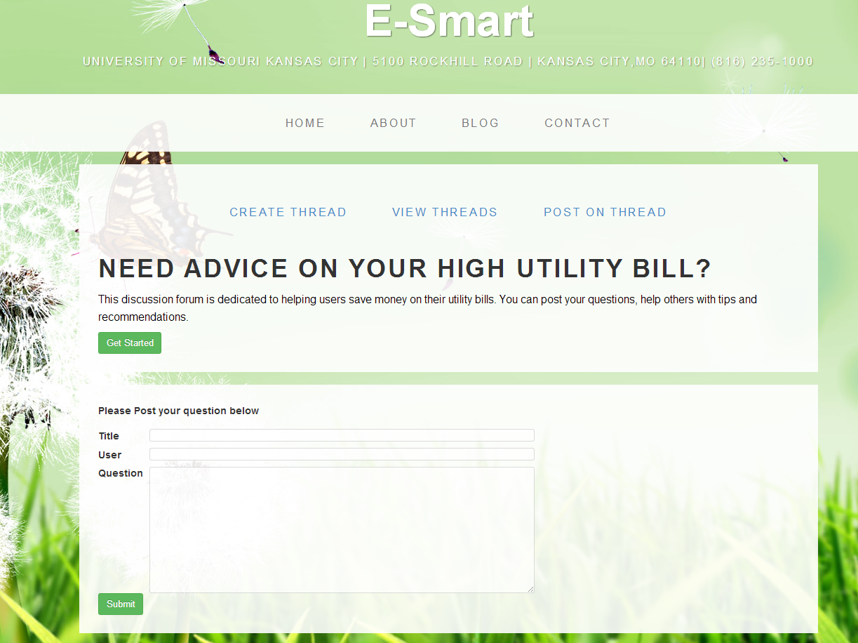

On clicking Submit the message is added to the forum in the database.

They can also view other’s threads and reply to their messages.

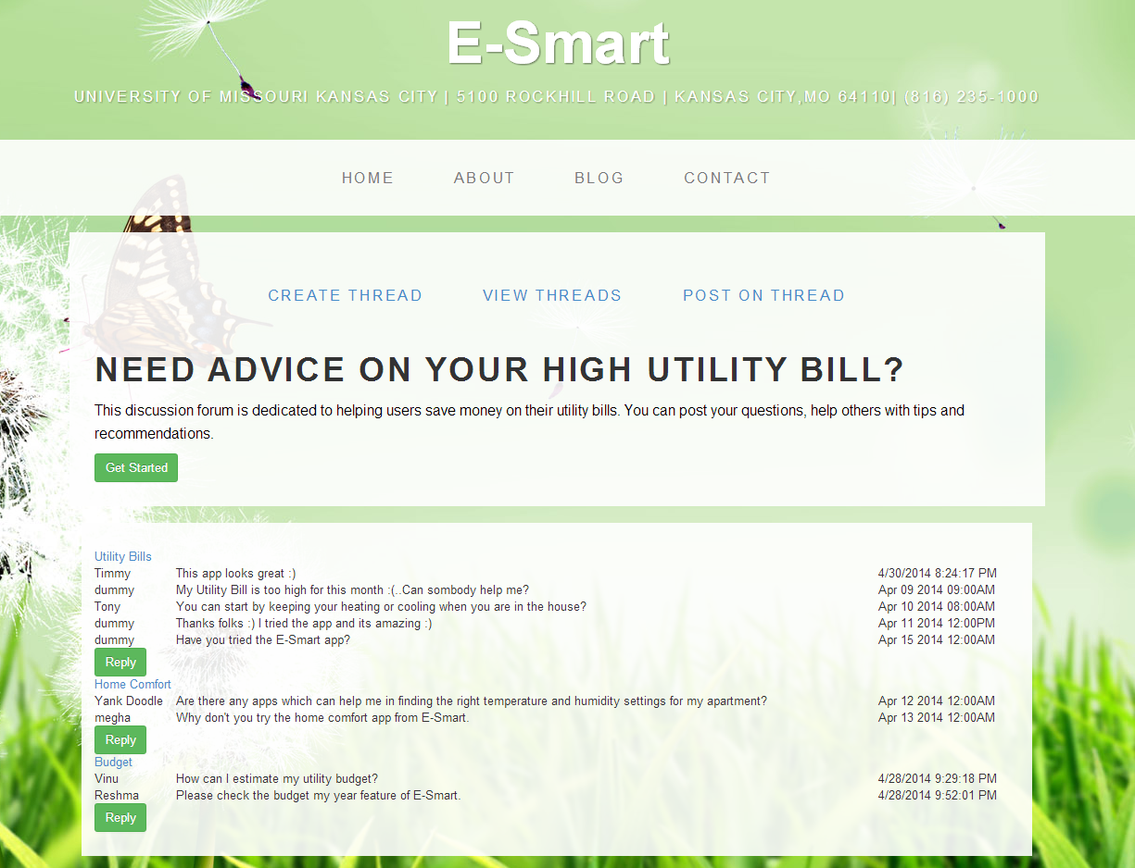

**Webservices/API:**

* The geocode function supported by the browser has been used to detect user’s current location.
* The “google.visualization.Gauge” has been used to create pie charts for the appliance utilization .
* SOAP Webservices have been used to populate forums and store user replies and create new threads.

**Design & Implementation details:**

User Clicks on the Dicussion Board image on homepage.

**Testing**

**SOAP Web Service Nunit Testing:**

**SoapServiceInsertTest:**

The **SoapServiceInsertTest** method test the InsertTable method in the Soap Web service. The InsertTable method inserts the user details entered in the Signup page into the Local SQL server database using the Soap Web service.

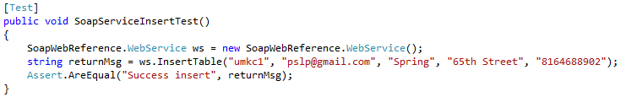

Test Result:

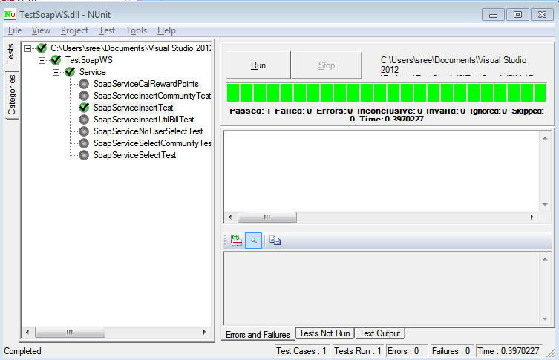

**SoapServiceNoUserSelectTest:**

The **SoapServiceNoUserSelectTest** method test the **GetUserData** method in the Soap Web service. The **GetUserData** method fetches the user details entered in the Login page from the Local SQL server database using the Soap Web service for user login verification and returns “user not exists”, if the user doesn’t already register.

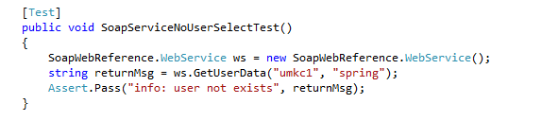

Test Result:

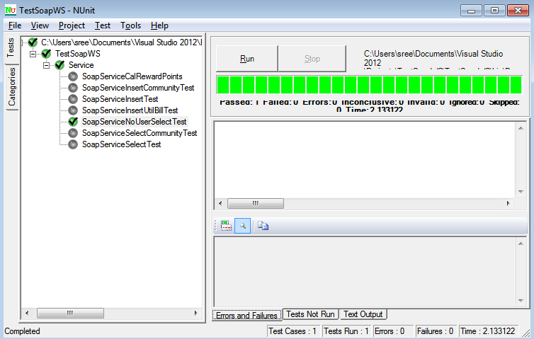

**SoapServiceSelectTest**

The **SoapServiceSelectTest** method test the **GetUserData** method in the Soap Web service. The **GetUserData** method fetches the user details entered in the Login page from the Local SQL server database using the Soap Web service for user login verification and returns “user exists”, if the user already register, username and password combination matches.

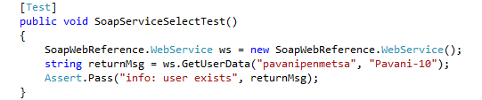

Test Result:

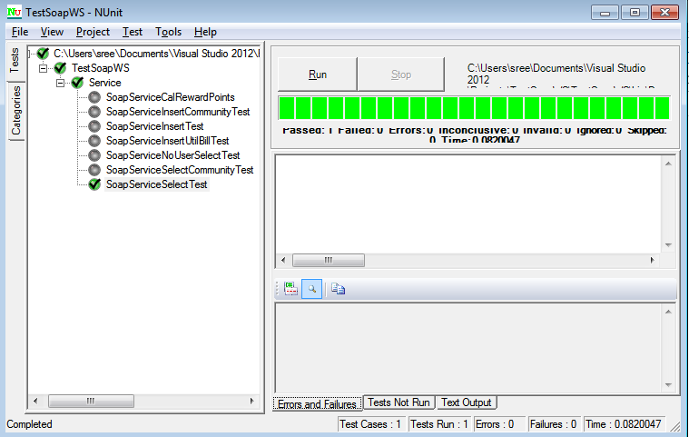

**SoapServiceInsertCommunityTest:**

The SoapServiceInsertCommunityTest method test the **InsertMyCommunity** method in the Soap Web service. The **InsertMyCommunity** method inserts the user house details and his community details entered in the JoinMyCommunity page into the Local SQL server database using the Soap Web service.

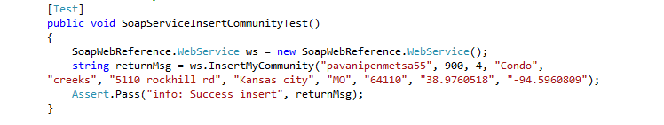

Test Result:

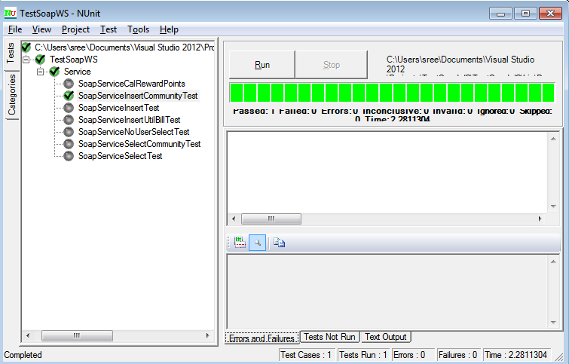

**SoapServiceSelectCommunityTest:**

The SoapServiceSelectCommunityTest method test the **selectCommunity** method in the Soap Web service. The **selectCommunity** method fetch the user house and community details from the Local SQL server database using the Soap Web service.

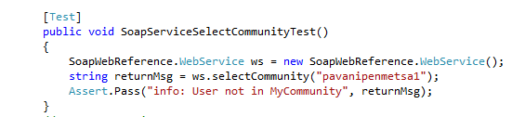

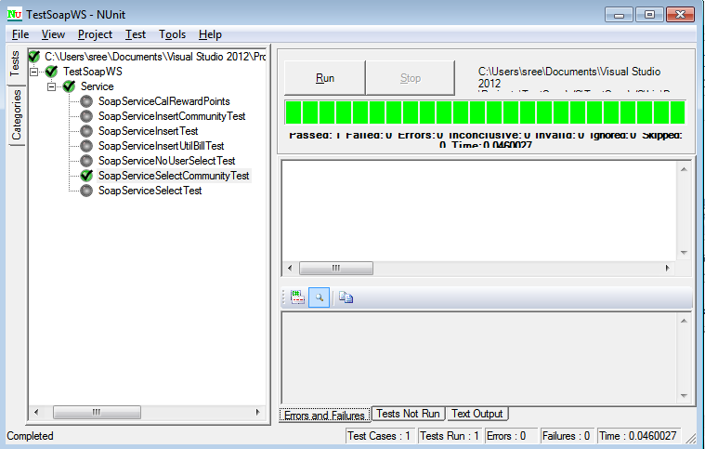

**SoapServiceInsertUtilBillTest:**

The SoapServiceInsertUtilBillTest method test the **InsertUtilityBill** method in the Soap Web service. The **InsertUtilityBill** method inserts the user utility bill details entered in the My Community – compute reward points pane into the Local SQL server database using the Soap Web service.

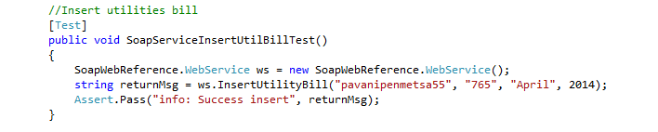

Test Result:

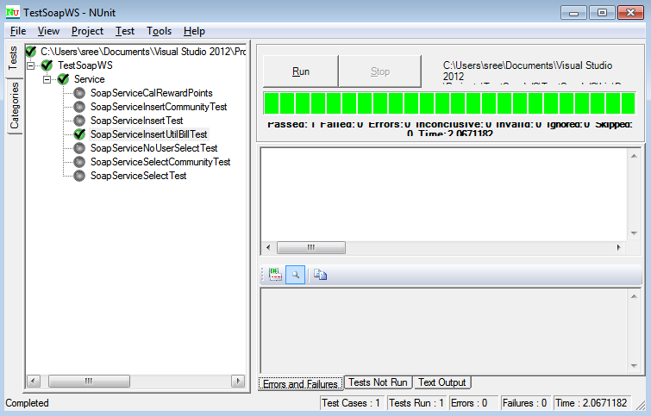

**SoapServiceCalRewardPoints:**

The SoapServiceCalRewardPoints method test the **CalculateRewardPoints** method in the Soap Web service. The **CalculateRewardPoints** method calcutes the users reward points compared with his neighbor’s utility bill with the data from the Local SQL server database using the Soap Web service.

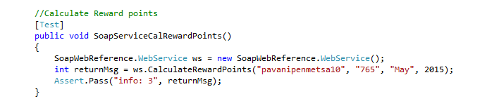

Test Result:

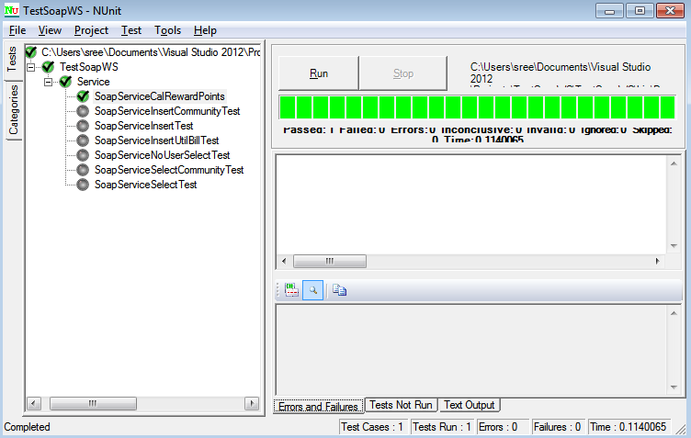

**SoapServiceCalComnRewardPoints:**

The SoapServiceCalComnRewardPoints method test the **CommunityRewardPoints** method in the Soap Web service. The **CommunityRewardPoints** method calculates all the users reward points who live in the same community with the data from the Local SQL server database using the Soap Web service.

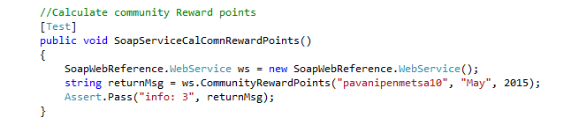

Test Result:

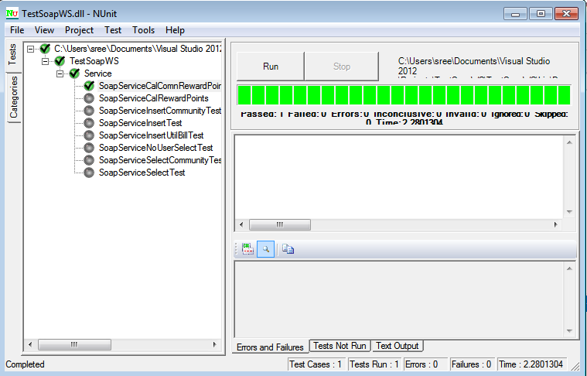

**SoapServiceCalnearComnRewardPoints:**

The SoapServiceCalnearComnRewardPoints method test the **RewardPointsByCommunity** method in the Soap Web service. The **RewardPointsByCommunity** method calculates all the nearby communities reward with the data from the Local SQL server database using the Soap Web service.

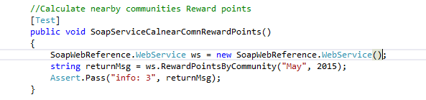

Test Result:

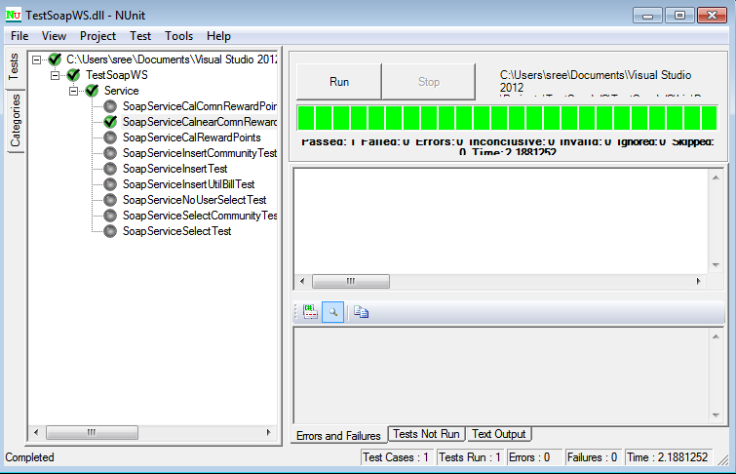

2.Below is the screenshot for NUnit Testing for getCityNotes Service methods. There are two test cases

1. For Valid city name that returns data
2. For Invalid city name that returns no data

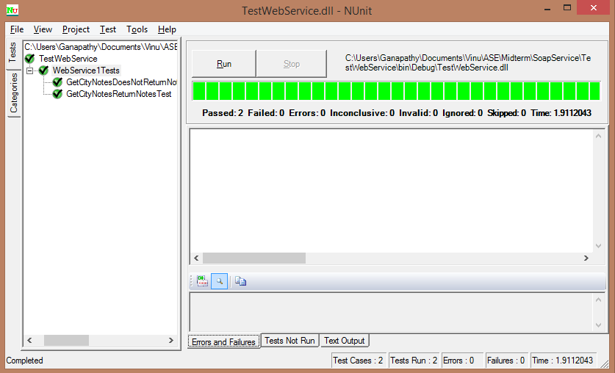

**Distribution of Work**

|  |  |  |
| --- | --- | --- |
| Responsibility | Time Taken | Person |
| My Community | 20 | Pavani |
| Homepage | 4 | All |
| Energy Analyzer and Recommendation System | 20 | Vinutha & Reshma |
| Discussion Board | 20 | Megha |
| Survey based Budget my year, Recommendation and Tip of the day | 20 | Megha and Reshma |
| Energy Efficient Homes | 18 | Pavani & Vinutha |
| Reporting & Unit Testing | 5 | All |
| Scrum Do | 2 | Reshma |

**Git Hub Repository:**

[**https://github.com/PavaniPenumathsa/ASE-Project-Phase-4**](https://github.com/PavaniPenumathsa/ASE-Project-Phase-4)

**ScrumDo:**

[**https://www.scrumdo.com/projects/project/esmart/iteration/92363**](https://www.scrumdo.com/projects/project/esmart/iteration/92363)

**URL for site:**

**C:\inetpub\wwwroot\aspnet_client\Group5\group5\Iteration-2\assets\html\homepage.html**